KAMPALA JUNIOR ACADEMY

HOLIDAY WORK SET TWO TERM I 2020
LITERACY I
PRIMARY TWO

My name is ________________________________________________
My school is _______________________________________________
1. Write words with these sounds.
(a) st ______________ (b) ch ____________
(c) ee ______________

2. Write out the domestic animals from the list below.
goat horse
buffalo leopard
cow pig
monkey lion
(a) _____________________
(b) _____________________
(c) _____________________

3. Arrange the letters to make correct words.
(a) shfi: ___________ (b) lotpi ____________

4. Use True/Untrue
(a) A young dog is a puppy. _______________
(b) A farmer flies an aeroplane. _________________
(c) Nimbus clouds give us rain. ________________

5. Match the parts correctly.
stem car
beat dog
horn cow
tail hen
tyre tree
6. Name these animals.
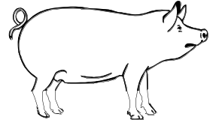 | 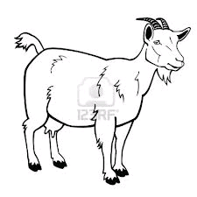 | 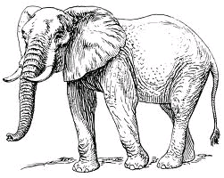

7. Read the dialogue and answer the questions.
Jane: Have you heard the news Sarah?
Sarah: What news?
Jane: Our friend John was bitten by a snake.
Sarah: Oh! Is he going to be alright?
Jane: Yes, he is going to be alright.
Questions:
- How many people are talking?
_____________________________________________________________________
- Who was the first to talk?
__________________________________________________
- Who was bitten by a snake?
_________________________________________________
8. Fill in the missing letters.
(a) fl__g (b) te__cher

9. Arrange these words to form correct sentences.
(a) are tall The trees.
________________________________________________
(b) basin The is soap in a.
___________________________________________________


10. Answer correctly in full sentences.
(a) What are these?
_______________________________________________
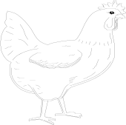
(b) Is this a hen?
_______________________________________________
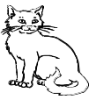
(c) Where is the cat?
____________________________________
11. Answer correctly.
(a) I look after the sick children at school. I work in the sickbay. I give medicine to the sick children.
Who am I?
___________________________________________________
(b) I am round and yellow. I give you light during day time. I dry your clothes during day time. What am I?

___________________________________________________
(c) I am made of wood. I have four legs. You sit on me. What am I?

___________________________________________________
(d) I have four legs. I live in a kraal. I give people milk and meat. My young one is a calf. Who am I?

___________________________________________________
12. Construct correct sentences using these words.
(a) by _____________________________________________
(b) buy _______________________________________________

13. Re-arrange the sentences to make a story.
Then, I put on my shoes.
I dry them with a towel.
I wear my stockings.
I wash my legs first.
Correct story
___________________________________________________
___________________________________________________
___________________________________________________
___________________________________________________
14. Match the words with similar sound.
feet sun
ship sit
goat fit
seat sheep
son got

15. Fill in the correct word from the brackets.

- A _______________ stays in a nest. (bird, bad)
- We ______________ food to get energy. (it, eat)
- Betty ______________ herself with a knife. (cat, cut)

16. Read and draw
(a) The cat is chasing a rat.

(b) The man is driving a car.

17. From the list below, tick √ the things you use to clean your body.

sponge desks nail cutter

soap hoe

** Best Wishes **

